1. Write a html code to create a nested table.

<!DOCTYPE html>

<html lang="en">

  <head>

    <title>NESTED TABLES</title>

    <style>

      table {

        text-align: center;

        border: 1px solid red;

        padding: 10px;

      }

      #one tr,

      #one th,

      #one td {

        border: 1px solid red;

        padding: 5px;

      }

      #two tr,

      #two th,

      #two td,

      #two {

        border: 2px solid green;

        padding: 5px;

      }

    </style>

  </head>

  <body>

    <table id="one">

      <tr>

        <th>row/Column</th>

        <th>1st</th>

        <th>2nd</th>

      </tr>

      <tr>

        <th>Saturday</th>

        <td>Database</td>

        <td>XML</td>

      </tr>

      <tr>

        <th>Sunday</th>

        <td>Java</td>

        <td>

          <table id="two">

            <tr>

              <th>Batch A</th>

              <th>Batch B</th>

            </tr>

            <tr>

              <td>HTML</td>

              <td>CSS</td>

            </tr>

          </table>

        </td>

      </tr>

    </table>

  </body>

</html>

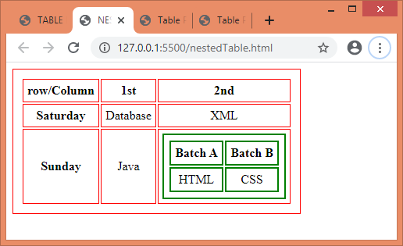

1. Write a html code to print:

a.

<!DOCTYPE html>

<html lang="en">

  <head>

    <title>Table Printing</title>

    <style>

      table {

        border: 1px solid;

        text-align: center;

        padding: 10px;

        border-collapse: collapse;

      }

      table th,

      tr,

      td {

        padding: 10px;

        border: 1px solid;

      }

    </style>

  </head>

  <body>

    <table width="400px">

      <tr>

        <th rowspan="3">SR.NO</th>

        <th colspan="4" width="70%">College Name</th>

      </tr>

      <tr>

        <th colspan="2">Section A</th>

        <th colspan="2">Section B</th>

      </tr>

      <tr>

        <th>X</th>

        <th>Y</th>

        <th>X</th>

        <th>Y</th>

      </tr>

      <tr>

        <th>1</th>

        <td colspan="4"></td>

      </tr>

      <tr>

        <th>2</th>

        <td colspan="4"></td>

      </tr>

      <tr>

        <th>3</th>

        <td colspan="4"></td>

      </tr>

    </table>

  </body>

</html>

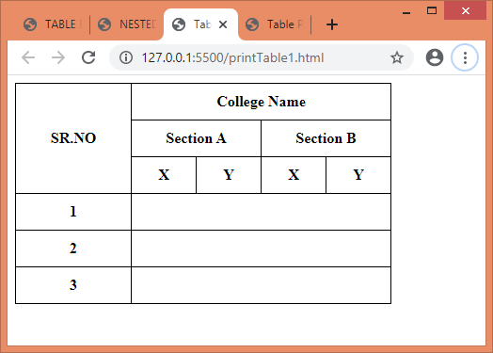

b.

<!DOCTYPE html>

<html lang="en">

  <head>

    <title>Table Printing</title>

    <style>

      table {

        border: 1px solid;

        text-align: center;

        padding: 10px;

        border-collapse: collapse;

      }

      table th,

      tr,

      td {

        padding: 10px;

        border: 1px solid;

      }

    </style>

  </head>

  <body>

    <table width="350px">

      <tr>

        <th width="20%" rowspan="2">Image</th>

        <th width="80%">Company name</th>

      </tr>

      <tr>

        <th>Schedule</th>

      </tr>

      <tr>

        <th>1</th>

        <td rowspan="2">Type 1</td>

      </tr>

      <tr>

        <th>2</th>

      </tr>

      <tr>

        <th>3</th>

        <td rowspan="2">Type 2</td>

      </tr>

      <tr>

        <th>4</th>

      </tr>

    </table>

  </body>

</html>

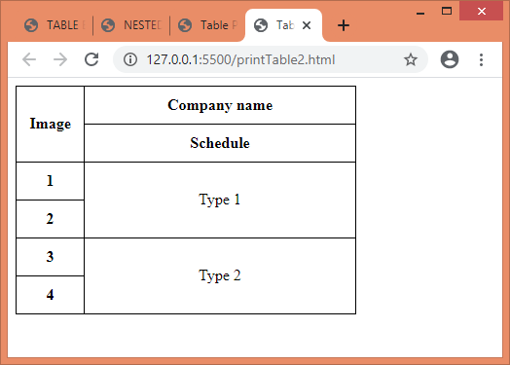

1. Create a html table with columns for country details.

<!DOCTYPE html>

<html lang="en">

  <head>

    <title>TABLE EXERCISES</title>

    <style>

      table {

        text-align: center;

        border: 1px solid;

        padding: 10px;

        border-collapse: collapse;

      }

      table tr,

      table th,

      table td {

        border: 1px solid;

        padding: 5px;

      }

    </style>

  </head>

  <body>

    <table>

      <tr>

        <th>COUNTRY NAME</th>

        <th>NATIONAL SPORT</th>

        <th>NATIONAL FLOWER</th>

        <th>NAITONAL BIRD</th>

        <th>NAITONAL TREE</th>

      </tr>

      <tr>

        <td>India</td>

        <td>Hockey</td>

        <td>Lotus</td>

        <td>Peacock</td>

        <td>Banyan</td>

      </tr>

      <tr>

        <td>Australia</td>

        <td>Cricket</td>

        <td>Acacias</td>

        <td>emu</td>

        <td>Golden wattle</td>

      </tr>

      <tr>

        <td>Japan</td>

        <td>Sumo wrestling</td>

        <td>Chrysanthemum</td>

        <td>Green pheasant</td>

        <td>Japanese Red Cedar Sugi</td>

      </tr>

      <tr>

        <td>New Zealand</td>

        <td>Rugby Union</td>

        <td>Kowhai</td>

        <td>Kiwis</td>

        <td>Silver-fern</td>

      </tr>

      <tr>

        <td>USA</td>

        <td>Baseball</td>

        <td>Rose</td>

        <td>Bald eagle</td>

        <td>Oak</td>

      </tr>

    </table>

    <br /><br /><br />

  </body>

</html>

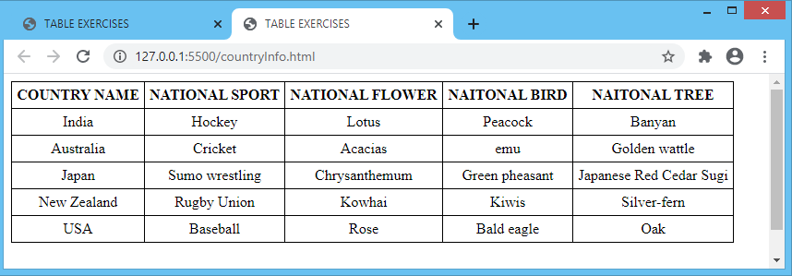

1. Write a code to implement your time-table..

<!DOCTYPE html>

<html lang="en">

  <head>

    <title>TABLE EXERCISES</title>

    <style>

      table {

        text-align: center;

        border: 1px solid;

        padding: 10px;

        border-collapse: collapse;

      }

      table tr,

      table th,

      table td {

        border: 1px solid;

        padding: 5px;

      }

    </style>

  </head>

  <body>

    <table>

      <tr>

        <th>Days/Time</th>

        <th>9.00am-10.00am</th>

        <th>10.30am-11.30am</th>

        <th>12.00pm-1.00pm</th>

        <th>2.00pm-3.00pm</th>

        <th>3.15pm-4.15pm</th>

      </tr>

      <tr>

        <th>Monday</th>

        <td>Computer Security</td>

        <td>Data Structure Using C</td>

        <td>Indusrial Training</td>

        <td>Enterpreneurship Development</td>

        <td>-</td>

      </tr>

      <tr>

        <th>Tuesday</th>

        <td>Internet & Web Designing</td>

        <td>Data Structure Using C</td>

        <td>-</td>

        <td>-</td>

        <td>Ecommerce</td>

      </tr>

      <tr>

        <th>Wednesday</th>

        <td>Computer Security</td>

        <td>Data Structure Using C</td>

        <td>-</td>

        <td>Enterpreneurship Development</td>

        <td>-</td>

      </tr>

      <tr>

        <th>Thursday</th>

        <td>Computer Security</td>

        <td>Internet & Web Designing</td>

        <td>-</td>

        <td>-</td>

        <td>Ecommerce</td>

      </tr>

      <tr>

        <th>Friday</th>

        <td>Internet & Web Designing</td>

        <td>Enterpreneurship Development</td>

        <td>-</td>

        <td>Ecommerce</td>

        <td>-</td>

      </tr>

    </table>

  </body>

</html>

